Supplementary Material 4. Funnel plots of the meta-analysis of studies examining the relationship between all cancer and alcohol consumption levels.

Light | Light to moderate
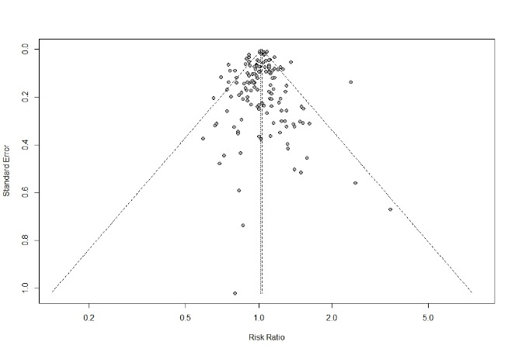 | 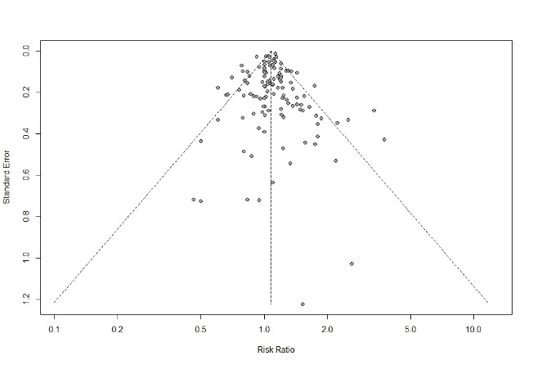
Egger test p-value = 0.42 | Egger test p-value = 0.56
Moderate to heavy | Heavy
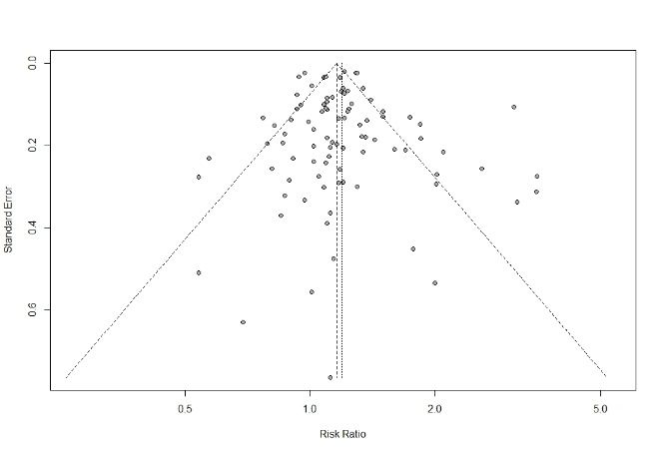 | 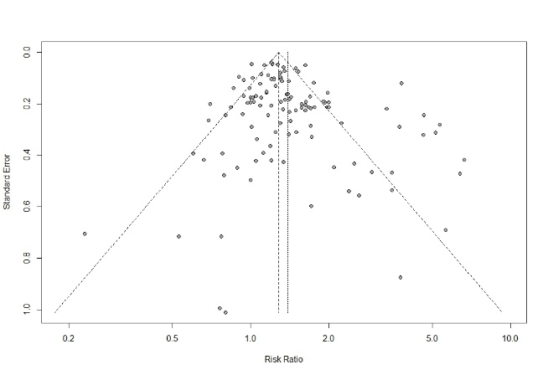
Egger test p-value = 0.39 | Egger test p-value = 0.01
The range of alcohol consumption levels was divided into light (0.01–12.4 g/day), light to moderate (12.5–24.9 g/day), moderate to heavy (25.0–49.9 g/day), and heavy (50.0+ g/day). RR, relative risk; 95% CI, 95% confidence intervals.
ª All cancer (esophageal cancer; stomach cancer; liver cancer; pancreatic cancer; colorectal cancer; laryngeal cancer; lung cancer; prostate cancer; breast cancer; thyroid cancer).

