Supplementary Material 1. Patterns of antihypertensive multidrug therapy using a hypothetical patient case for measuring adherence estimates by the predefined six measurements
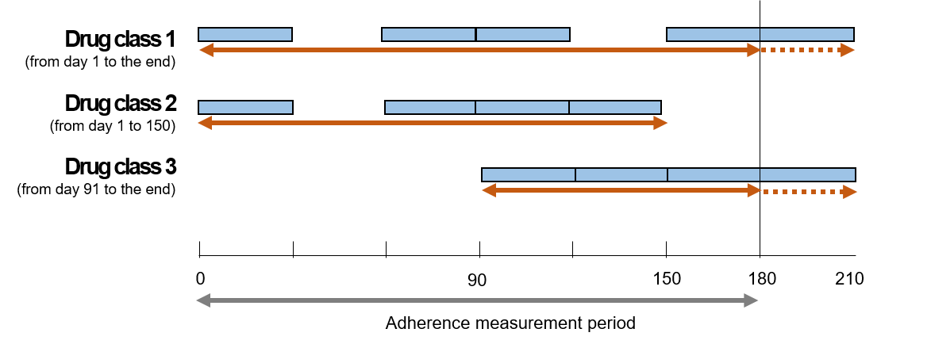
Prescription-based methodology (PxM)
PDC_{with≥1} | = 180 days covered / 210 days = 85.7%
PDC_{wm} | = (71.43% $×$ 210 + 80% $×$ 150 + 100% $×$ 120) / (210 + 150 + 60) = 81.25 %  - PDC of class 1 = (150 days covered / 210 dyas) _{day 1 to 210} = 71.43%  - PDC of class 2 = (120 days covered / 150 dyas) _{day 1 to 150} = 80%  - PDC of class 3 = (120 days covered / 120 dyas) _{day 91 to 210} = 100%
DPPR | = [(2/$2×3$0)_{day 1 to 30}$+$(0/2$×3$0) _{day 31 to 60}$+$(2/2$×3$0)$\text{day 61 to 90}+$  (3/$3×3$0) _{day 91 to 120} $+$(2/3$×3$0) _{day 121 to 150} $+$(2/2$×6$0) _{day 151 to 210}] / 210  = 80.95%
Fixed period-based methodology (FxM)
PDC_{with≥1} | = 150 days covered / 180 days = 83.3%
PDC_{wm} | = (66.67% $×$ 180 + 80% $×$ 150 + 100% $×$ 90) / (180 + 150 + 90) = 78.57 %  - PDC of class 1 = (120 days covered / 180 dyas) _{day 1 to 180} = 66.67%  - PDC of class 2 = (120 days covered / 150 dyas) _{day 1 to 150} = 80%  - PDC of class 3 = (90 days covered / 90 dyas) _{day 91 to 180} = 100%
DPPR | = [(2/$2×3$0)_{day 1 to 30}$+$(0/2$×3$0) _{day 31 to 60}$+$(2/2$×3$0)$\text{day 61 to 90}+$  (3/$3×3$0) _{day 91 to 120} $+$(2/3$×3$0) _{day 121 to 150} $+$(2/2$×$30) _{day 151 to 180}] / 180  = 77.78%

Abbreviation: DPPR, daily polypharmacy possession ratio; FxM, fixed period-based methodology; PDC_{with≥1}, proportion of days covered with at least one drug; PDC_{wm}, duration weighted mean proportion of days covered; PxM, prescription-based methodology

