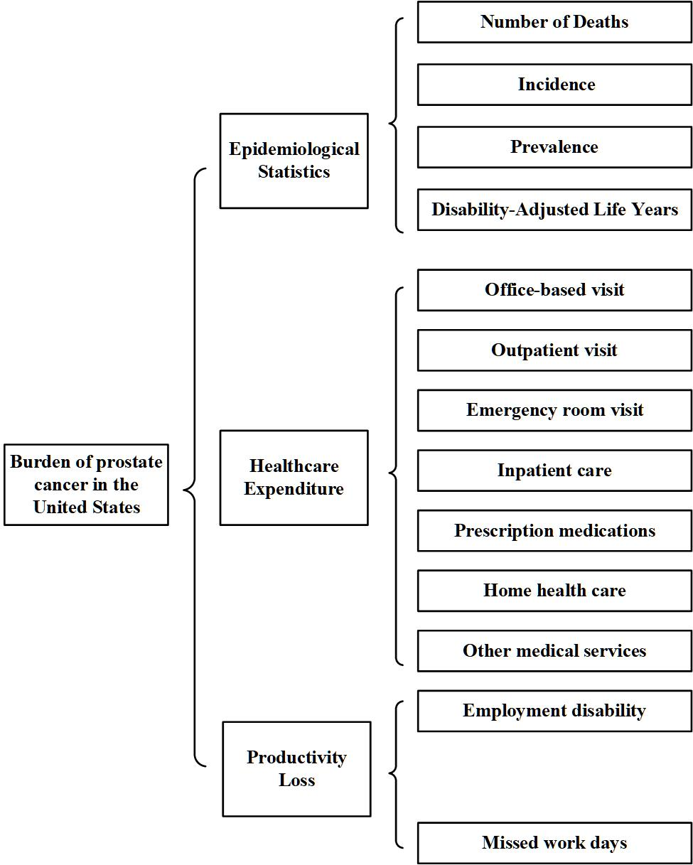

Supplementary Fig 2. Diagram of outcome measured in the study.

