Supplemental Material 4. Estimates of the cumulative incidence for primary outcome according to the use of statins after retinal vein occlusion
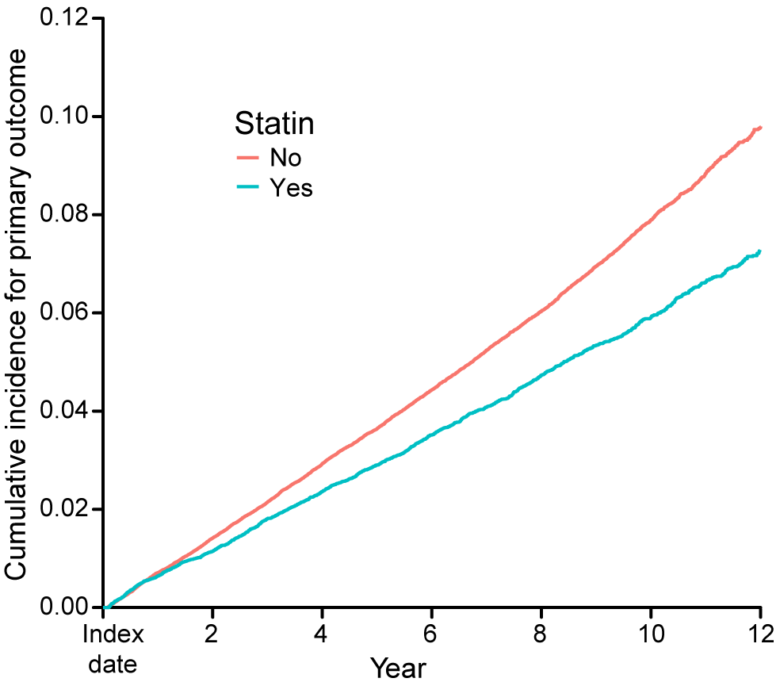
Simon-Makuch plot illustrates the cumulative incidence for primary outcome (stroke and myocardial infarction) according to the use of statins after retinal vein occlusion.

