Supplementary Material 1. Changes in eating behaviors by high and low household income in adolescents (12-18 years old) from 2016 to 2020.
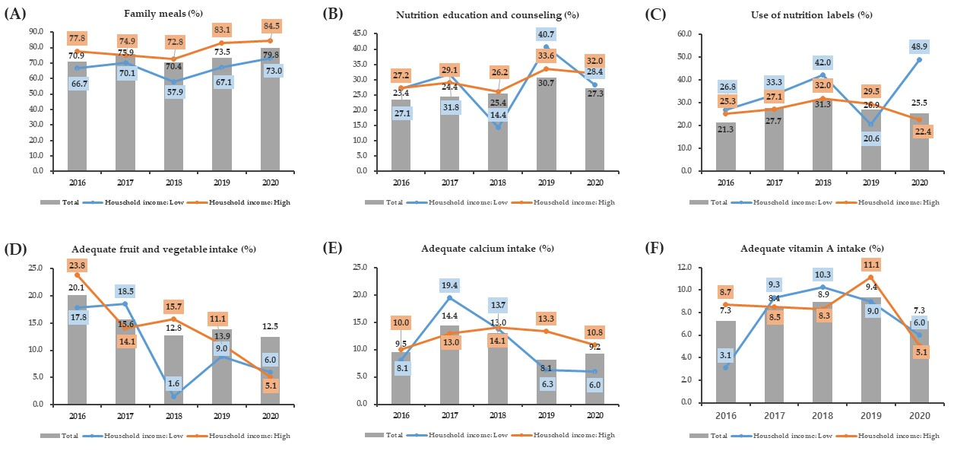
Results are expressed as a weighted percentage (%) taking into account the sampling method.

Supplementary Material l. (Continued).
