Supplementary Material 1. Flowchart of the study population

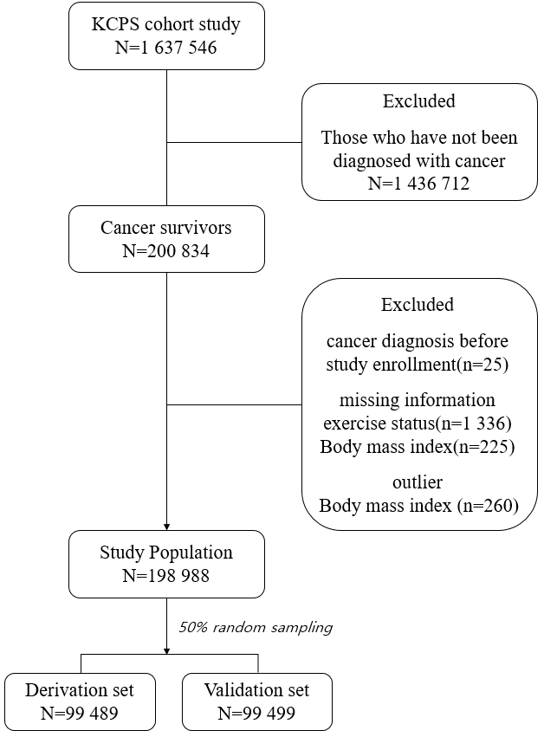
- BMI outlier is an extremely high (>100 kg/m2) or low BMI (<16 kg/m2)

