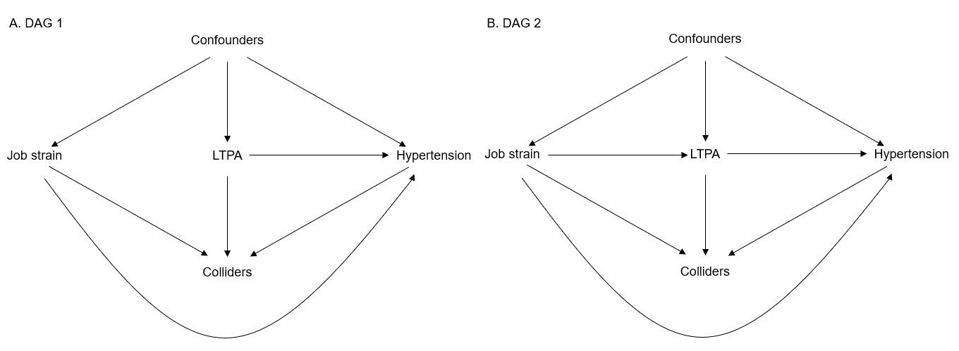 Abbreviations: DAG, directed acyclic graph; LTPA, leisure-time physical activity.
Supplementary Material 2. Directed acyclic graphs (DAGs) for the associations of baseline job strain and leisure-time physical activity with incident hypertension

