Supplement 4. Funnel plot and Egger’s test for assessing publication bias by cancer type

Breast cancer

Egger’s test: Coefficient (95% CI): 0.34(-0.11, 0.78) p = 0.07

Funnel Plot
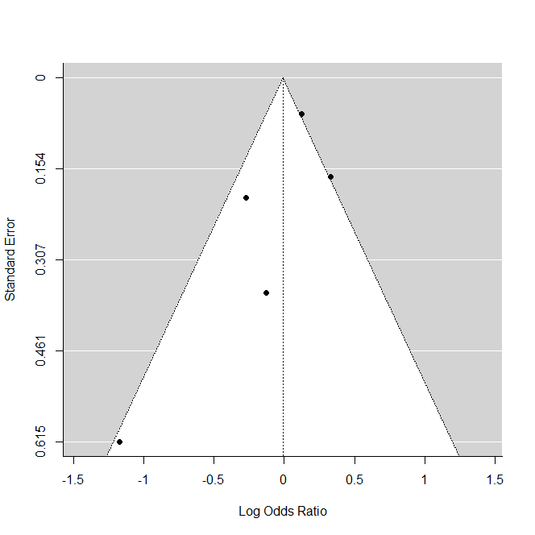

Colorectal cancer

Egger’s test: Coefficient (95% CI): -0.29 (-0.64, 0.06) p = 0.27

Funnel plot

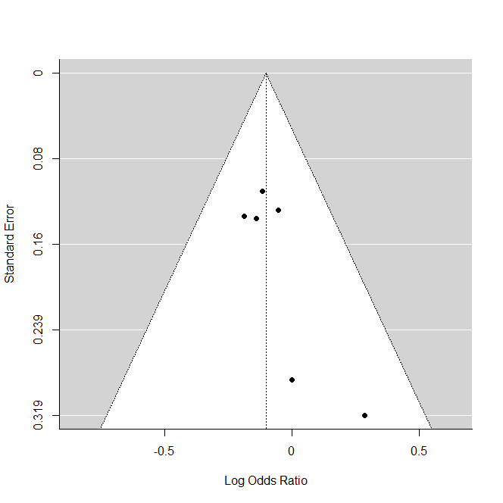

Liver cancer
Egger’s test: Coefficient (95% CI): 0.49 (-0.07, 1.04) p=0.12
Funnel plot
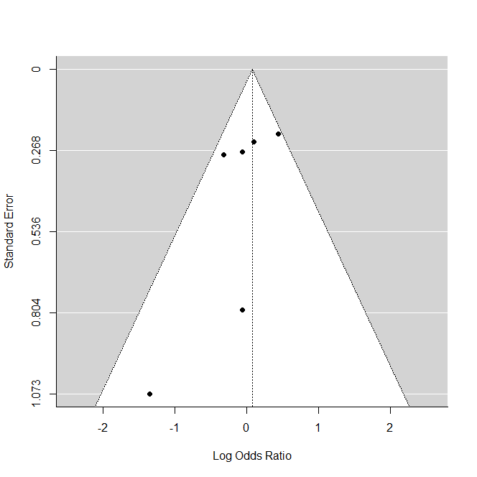

Lung cancer
Egger’s test: Coefficient (95% CI): -0.01 (-0.26, 0.23) p = 0.96

Funnel Plot

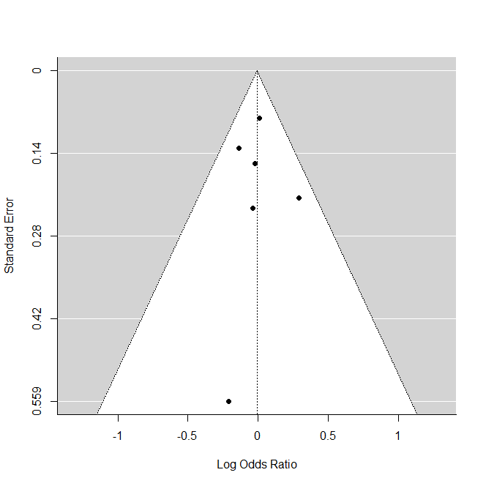

Lymphohematopoiteic cancer

Egger’s test: Coefficient (95% CI): -0.16 (-0.56, 0.24) p = 0.56

Funnel Plot
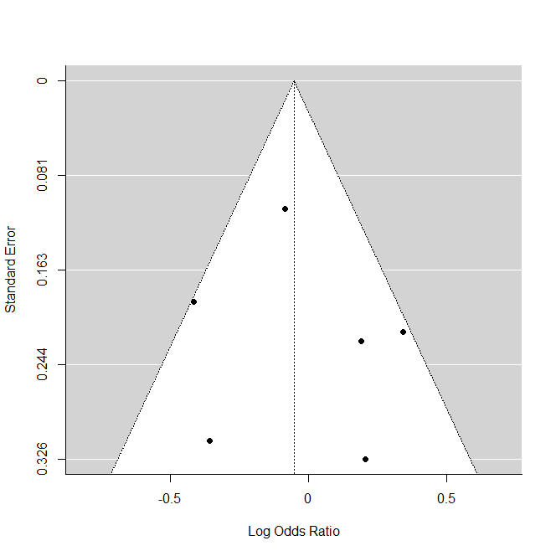

NHL

Egger’s test: Coefficient (95% CI): 0.99 (-1.24, 3.22) p=0.31

Funnel Plot
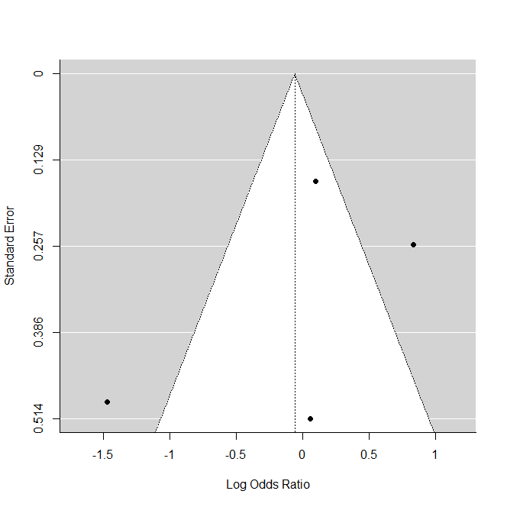

Sarcoma

Egger’s test: Coefficient (95% CI): -0.24 (-3.97, 4.45) p = 0.68

Funnel Plot
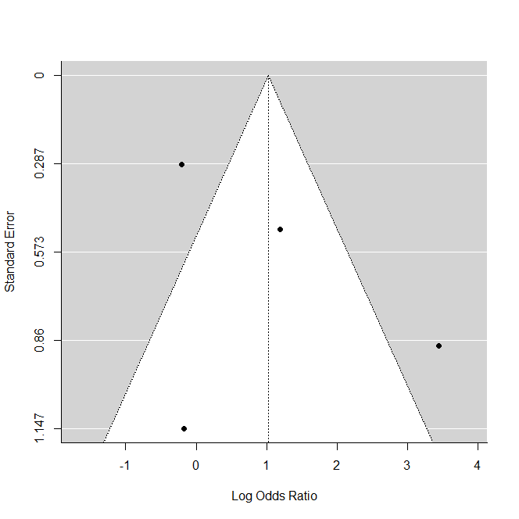

Stomach cancer

Egger’s test: Coefficient (95% CI): -0.25 (-0.90, 0.39) p=0.46

Funnel Plot
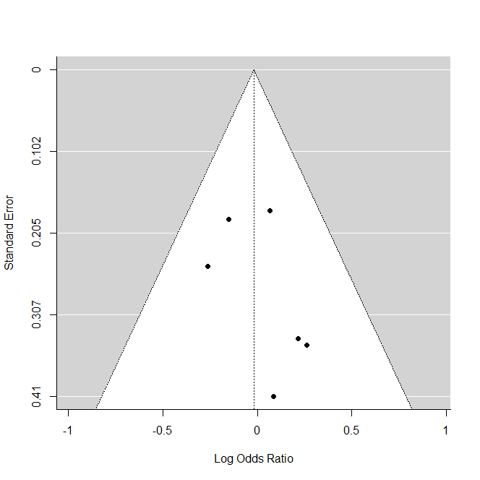

All cancer (from literature reporting ‘all cancer’)
Egger’s test: Coefficient (95% CI): -0.01 (-0.04, 0.03) p=0.19

Funnel Plot 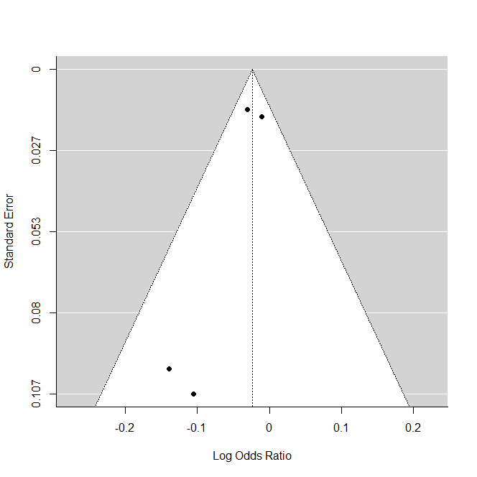

Bladder cancer
Egger’s test: Coefficient (95% CI): -0.22 (-0.95, 0.51) p=0.55

Funnel Plot
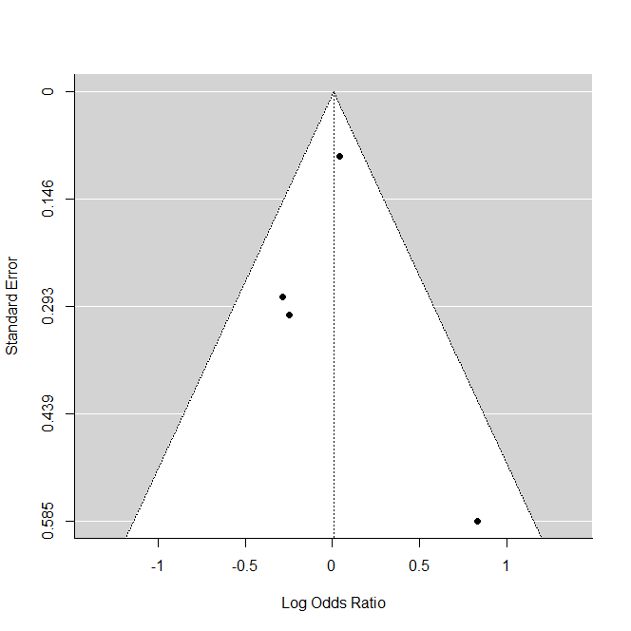

CNS cancer
Egger’s test: Coefficient (95% CI): -0.40 (-1.35, 0.55) p = 0.50

Funnel Plot
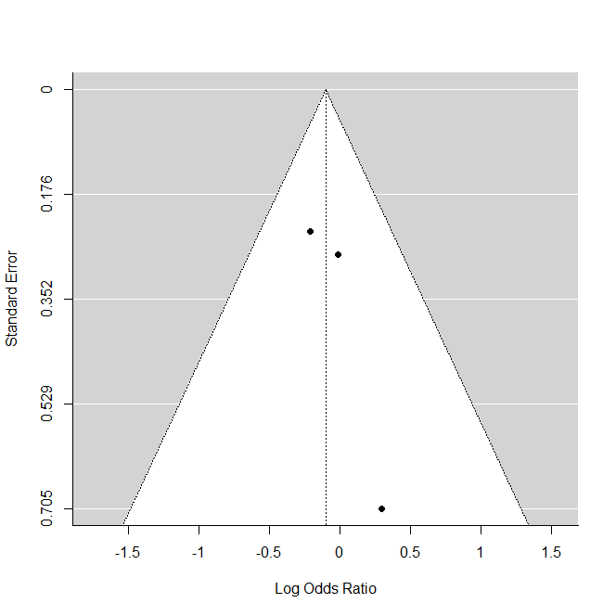

Laryngeal cancer
Egger’s test: Coefficient (95% CI): 0.58 (-0.29, 1.45) p = 0.25

Funnel Plot
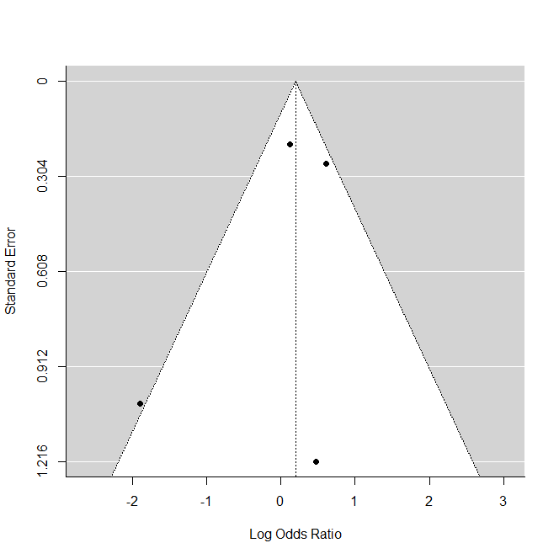

Leukemia
Egger’s test: Coefficient (95% CI): 0.99 (-1.01, 2.98) p = 0.51
Funnel Plot
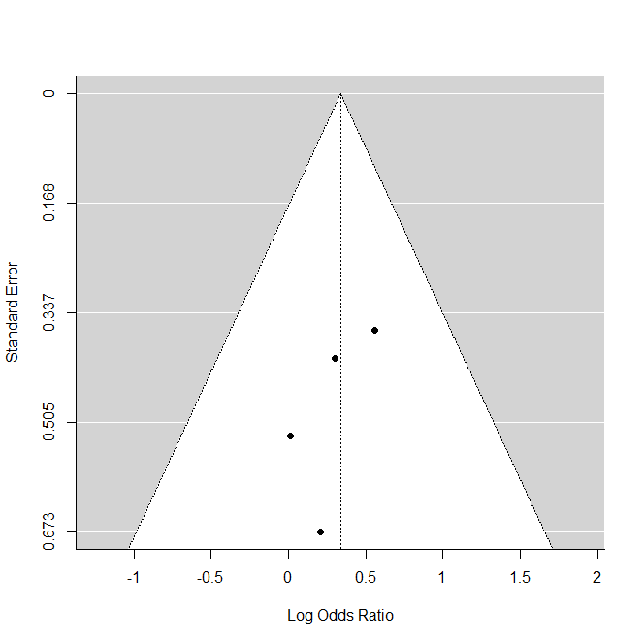

All cancer (pooled all effect size identified regardless of types)
Egger’s test: Coefficient (95% CI): -0.03 (-0.05, -0.01) p = 0.08
Funnel Plot
