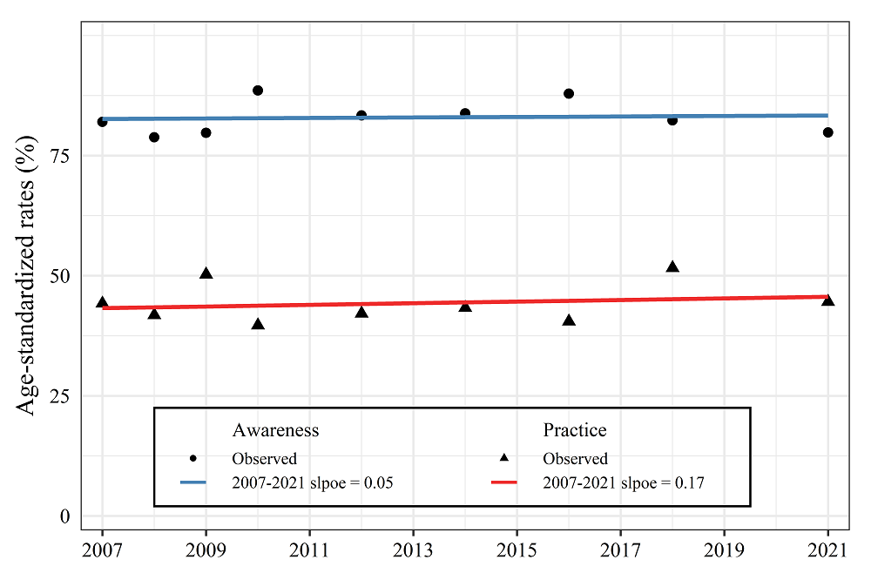
Supplementary Material 4. The awareness and practice of cancer prevention, 2007-2021
n = number of survey participants
The practice was calculated among participants who are aware of cancer prevention in 2007-2009. From 2010, it was calculated among all participants. Trends in the ASRs summarized as APC using a linear model without log-transformation. The APC was calculated using age-standardized rate (ASRs) based on 2015 mid-year population statistics.
* Significantly different from zero (p-value < 0.05)

