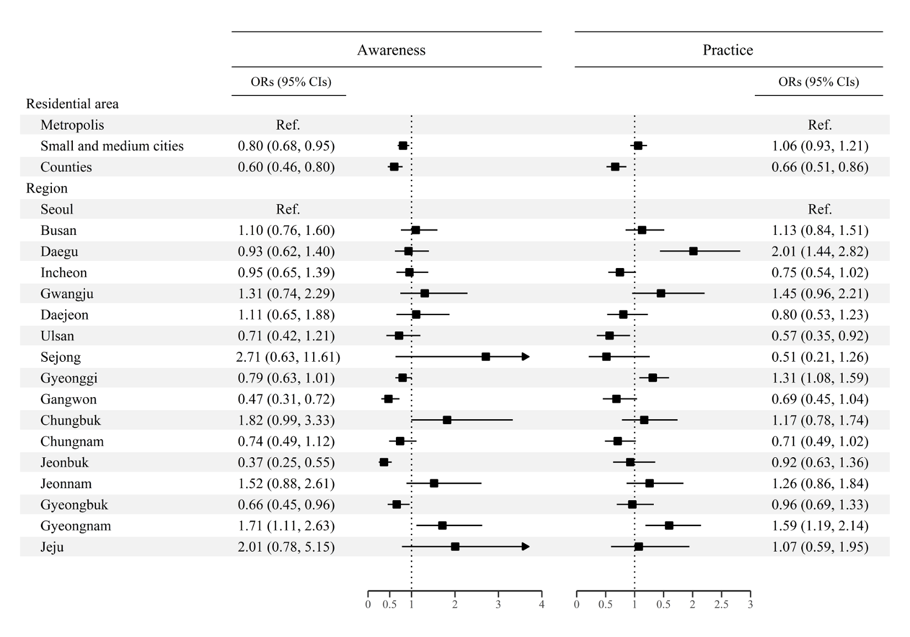
Supplementary Material 3. Odds ratios and 95% of confidence intervals of the awareness and practice of cancer prevention by region in 2021. The odds ratios were adjusted for age and sex using a logistic regression model

