Online supplementary material

This appendix is a part of the original submission and has been peer reviewed.

Supplement to: Jung S and Park S. Positive association of unhealthy plant-based diets with the incidence of abdominal obesity: a comparison of baseline, most recent, and cumulative average diets

Supplementary Material 1. Participant flow chart
Supplementary Material 2. Food items listed in the FFQ with 103 items and the FFQ with 106 items in the KoGES_Ansan Ansung Study
Supplementary Material 3. Illustration of the three approaches for analyzing repeated dietary measurements in the KoGES Ansan and Ansung Study
Supplementary Material 4. Food items constituting the 17 food groups using the KoGES_Ansan Ansung Study
Supplementary Material 5. Age- and sex-adjusted nutritional characteristics of the study participants according to 3 different plant-based diet indices (n=6054)
Supplementary Material 6. Age- and sex-adjusted food group intakes of the study participants according to 3 different plant-based diet indices (n=6054)
Supplementary Material 7. Adjusted HRs and 95% CIs for incident abdominal obesity according to the continuous uPDIs using restricted cubic splines
Supplementary Material 8. Hazard ratios (HRs) and 95% confidence intervals (CIs) for abdominal obesity according to the plant-based diet indices with salted vegetables categorized into the healthy plant food group (n=6054)
Supplementary Material 9. Hazard ratios (HRs) and 95% confidence intervals (CIs) for abdominal obesity according to plant-based diet indices after excluding incident cases of abdominal obesity occurring within the first two follow-up years (n=5538)
Supplementary Material 10. Hazard ratios (HRs) and 95% confidence intervals (CIs) for abdominal obesity according to the plant-based diet indices after excluding incident cases of hypertension, T2DM, dyslipidemia, and general obesity occurring before the development of abdominal obesity during the follow-up (n=5656)

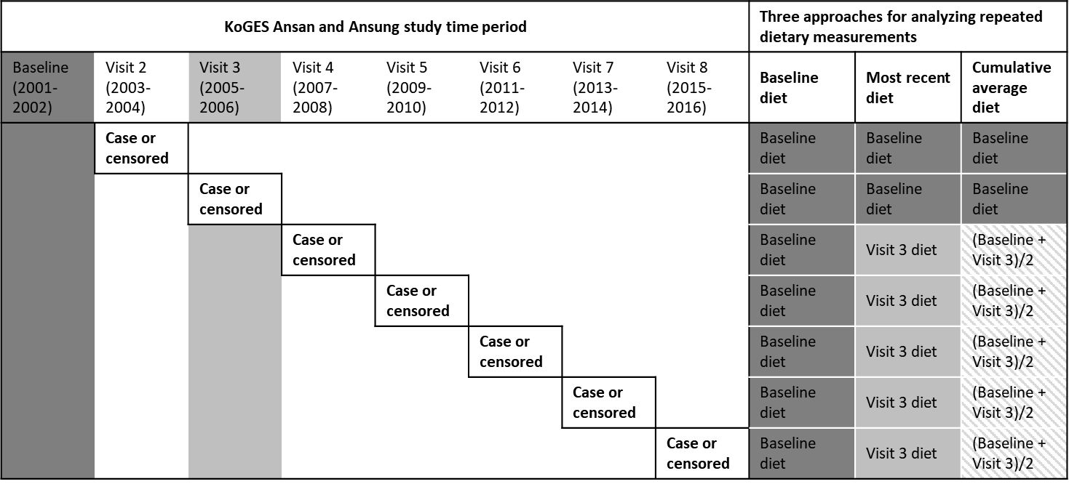
Supplementary Material 3. Illustration of the three approaches for analyzing repeated dietary measurements in the KoGES Ansan and Ansung Study.

