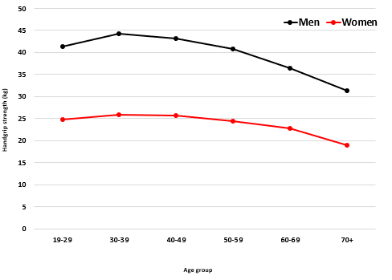
Supplementary Material 5. Mean handgrip strength by age groups in men and women.

