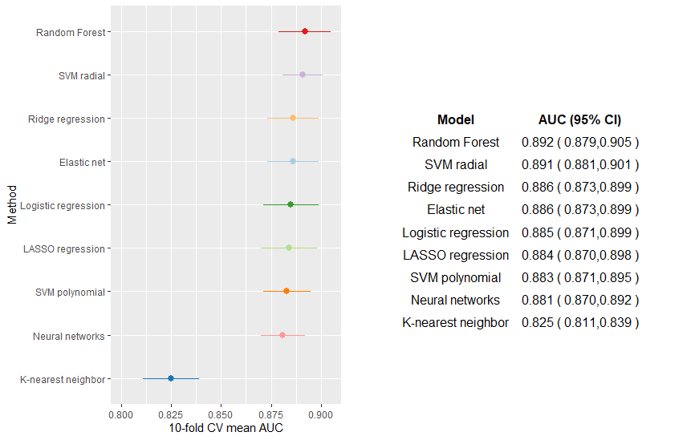
Supplementary Material 8. Cross-validated performance of the machine learning algorithms according to the area under the curve (AUC) in sensitivity analyses 2 and 3. CV, cross-validation; CI, confidence interval.

