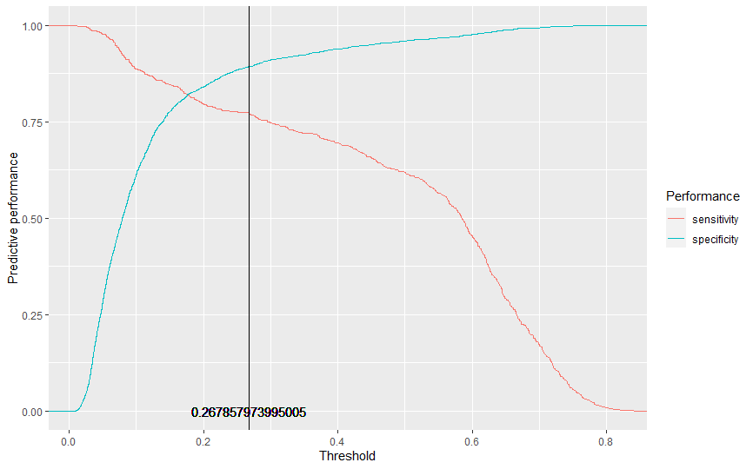
Supplementary Material 5. Predictive performance of the best-performing machine learning algorithm (random forest) across different probability threshold values, and the optimal value of probability threshold for classification.

