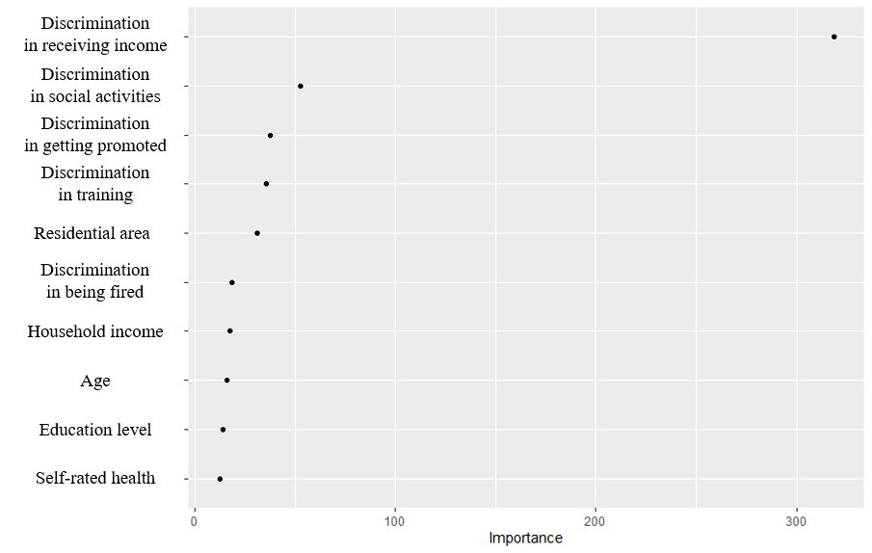
Supplementary Material 4. Variable importance scores for the predictors in the best-performing machine learning algorithm (random forest).

