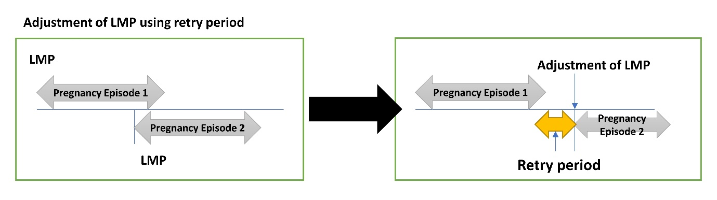
Supplementary Material 8 Illustration of LMP adjustment by retry period

