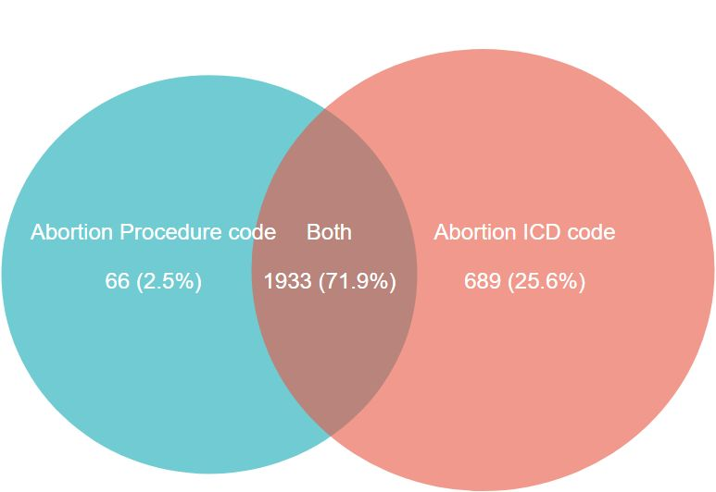
Supplementary Material 3 Distribution of procedure codes and diagnosis codes for abortion

