Supplement 5. ACF plot of residuals.
Period | School admission cohort
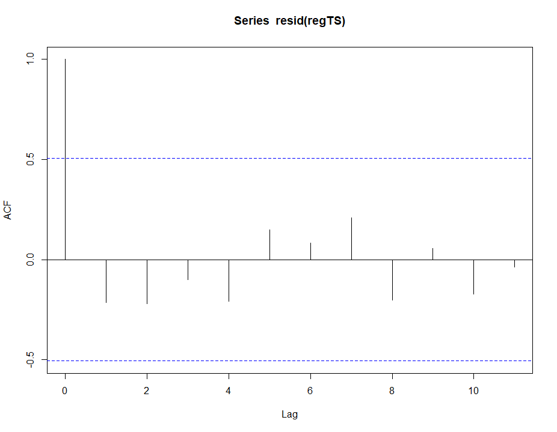  - Boys: Complete smoking ban in public space with increased penalties in December 2011. | 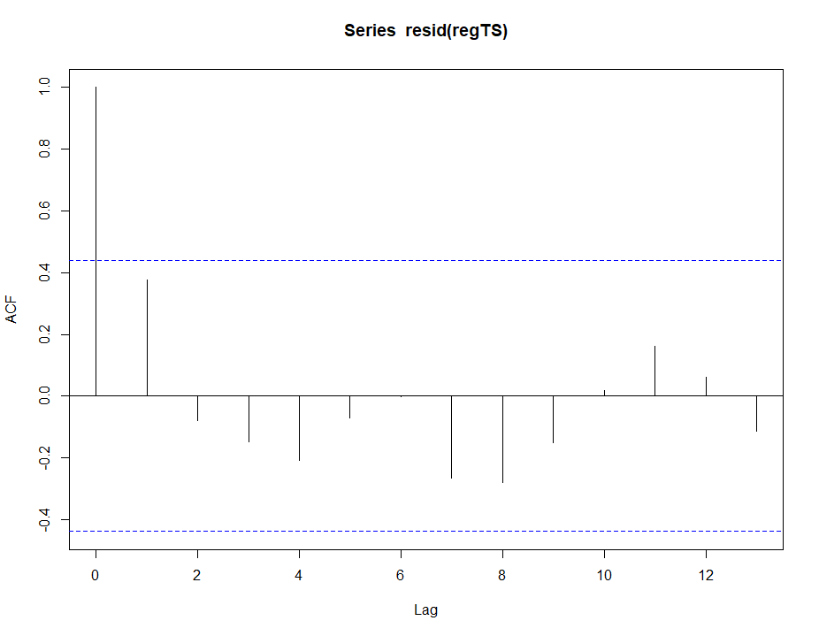  - Boys: ‘Say No, Save Lives’ campaign in 2008.
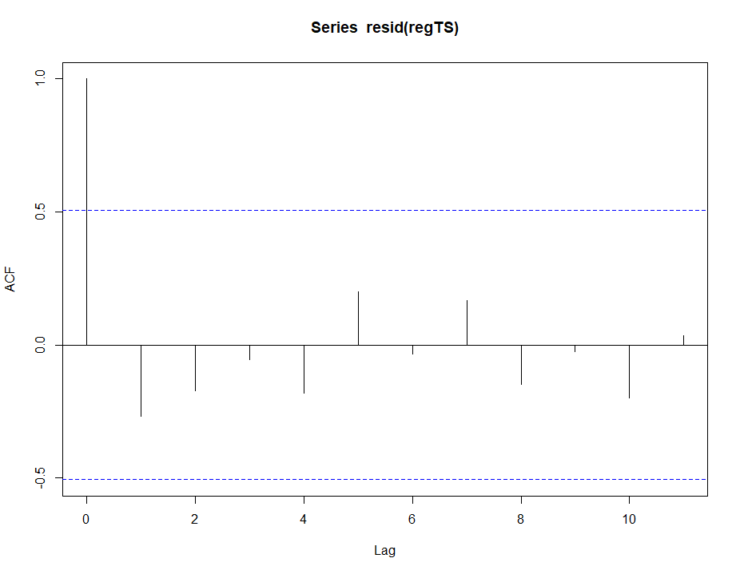  - Girls: Complete smoking ban in public space with increased penalties in December 2011. | 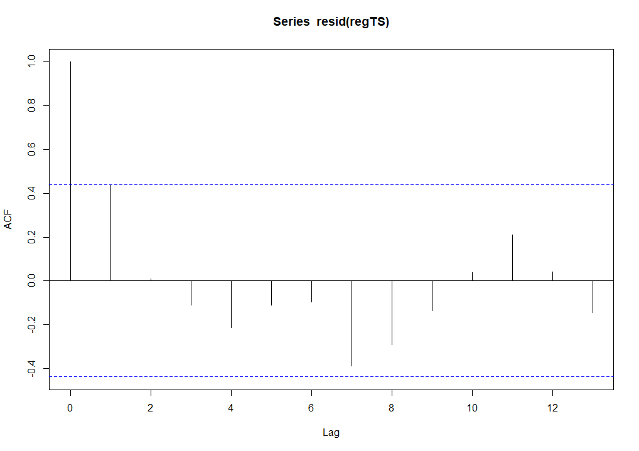  - Girls: ‘Say No, Save Lives’ campaign in 2008.

