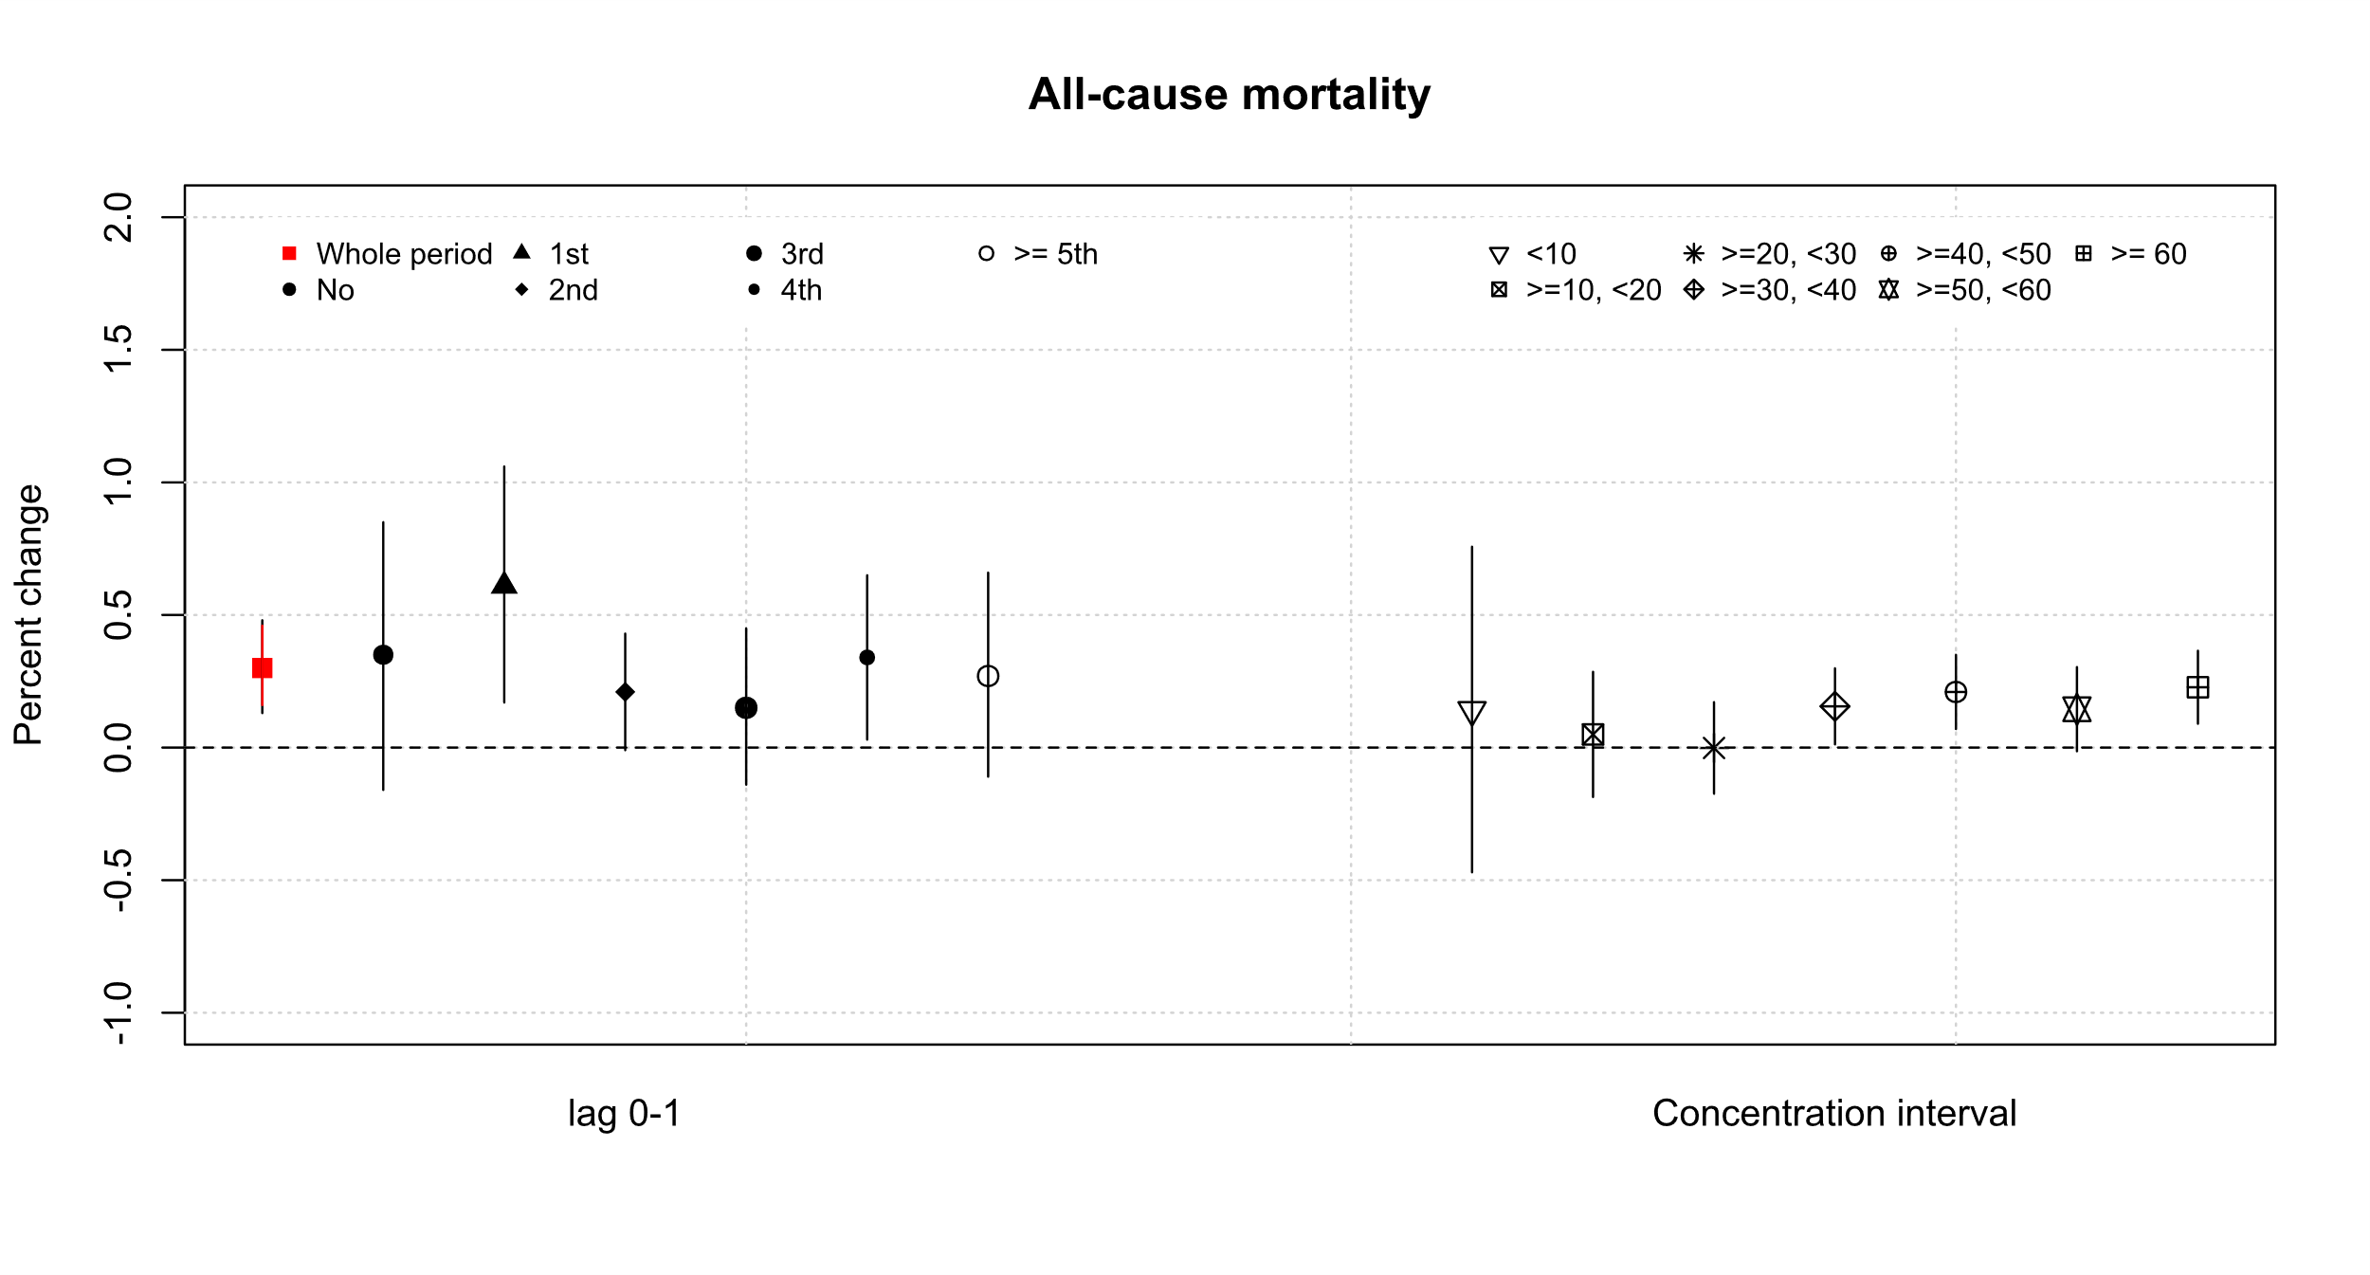
Supplementary Material 10. Comparison of the effect modifications of pooled effect estimates (all-cause mortality risk percent changes per 10 μg/m³ increase of daily lag 0-1) of the average of same-day exposure to PM_{2.5} and PM_{2.5} exposure 1 day prior. Left is according to consecutive days, and right is to background mean concentration interval (μg/m³).

