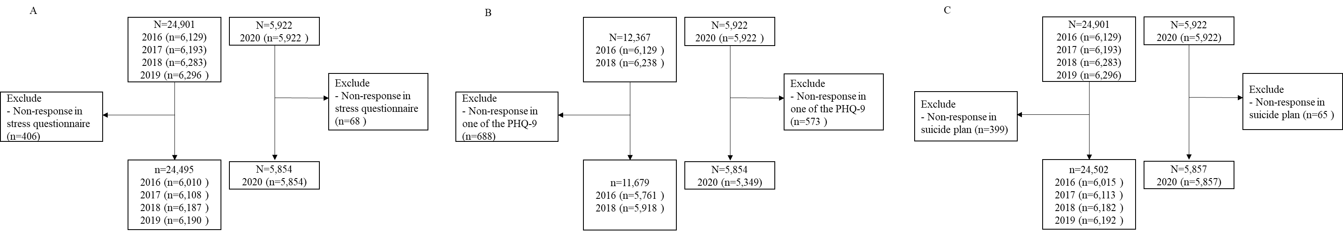
Supplementary Material 1. Flowchart of the included analysis samples in each outcomes
A: analysis for severe perceived stress; B: analysis for depression; C: analysis for suicidal plans

