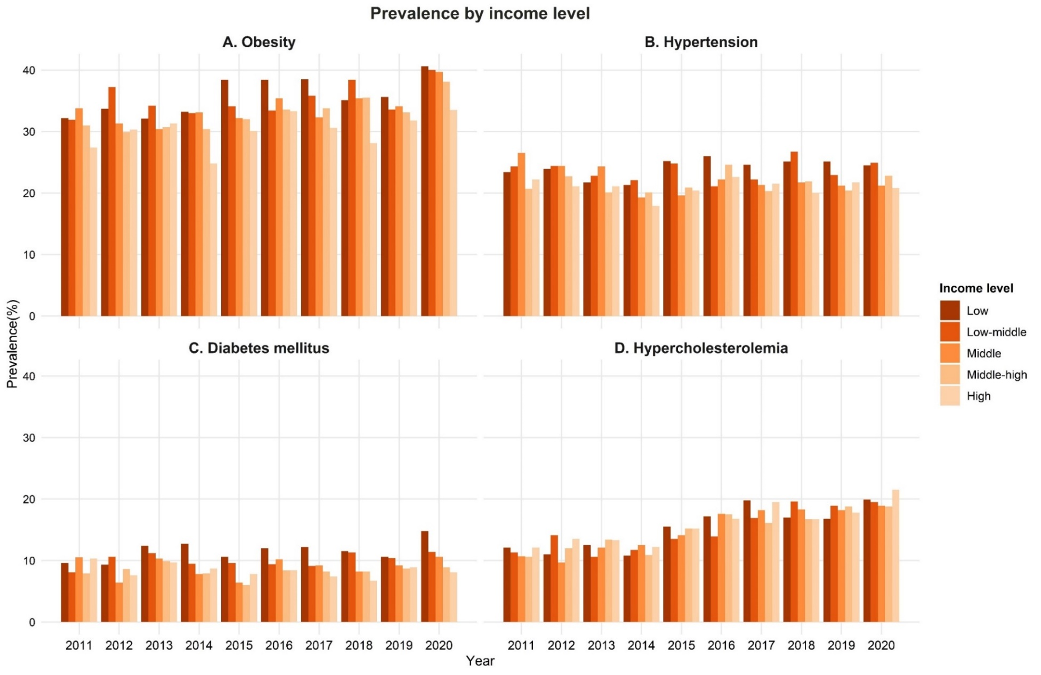
Supplementary Material 6. Prevalence by income level in obesity, hypertension, diabetes mellitus, and hypercholesterolemia.

