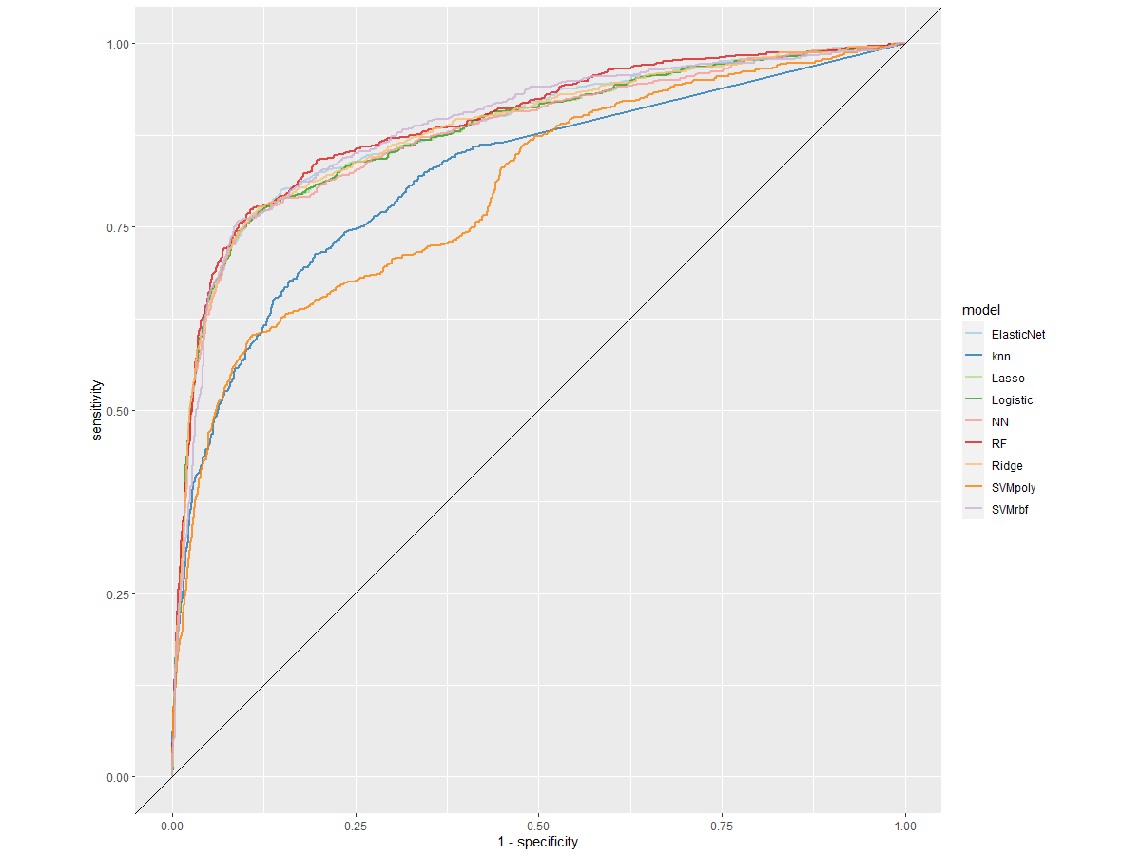
Supplementary Material 3. Receiver operating characteristic (ROC) curve of the cross-validated classification performance of each model

