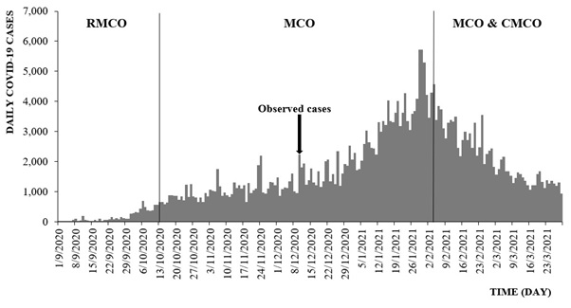
Supplementary Material 1. Daily COVID-19 cases across various movement control order, September 1, 2020 to March 29, 2021, Malaysia. RMCO, recovery movement control order; MCO, movement control order; CMCO, conditional movement control order; COVID-19, coronavirus disease 2019.

