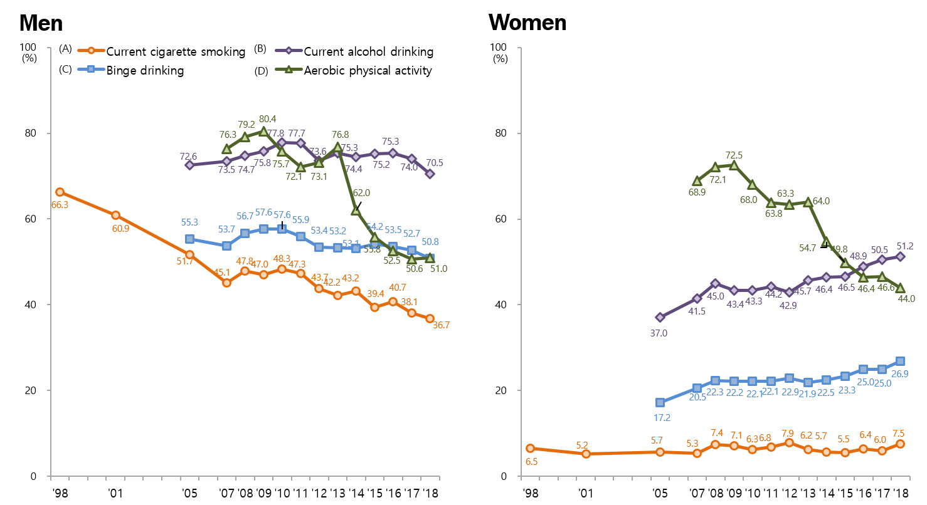
Supplementary Material 1. Trends in health behaviors in Korea National Health and Nutrition Examination Survey. (A) Current cigarette smoking: percentage of adults who have smoked at least 100 cigarettes during their lifetime and who are currently smokers, (B) Current alcohol drinking: percentage of adults who have had alcoholic drinks 1 or more times a month during the past year, (C) Binge drinking: percentage of adults who have drunk ≥ 7 (men) or ≥ 5 (women) alcoholic drinks more than once a week during the past year, (D) Aerobic physical activity: percentage of adults who have performed 150 minutes of moderate-intensity physical activity or 75 minutes of vigorous-intensity physical activity or an equivalent combination of moderate- and vigorous-intensity physical activity in a typical week.

